Paragraph structure 1:

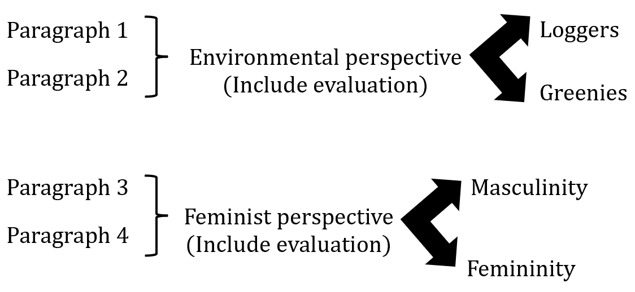

Paragraph structure 2:

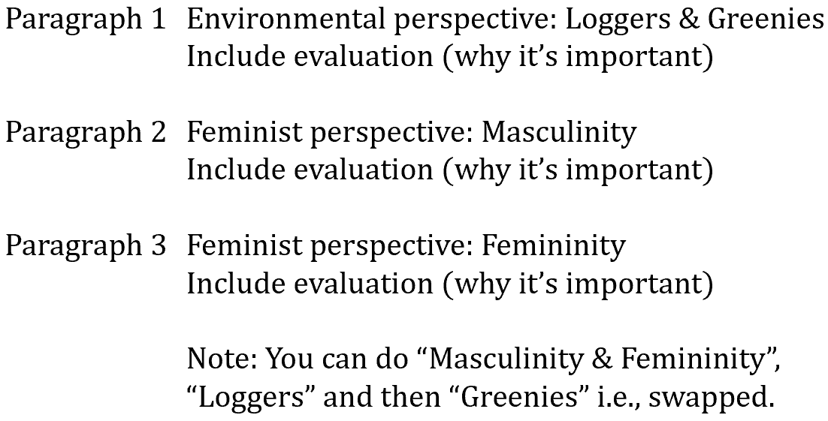

Paragraph structure 3:

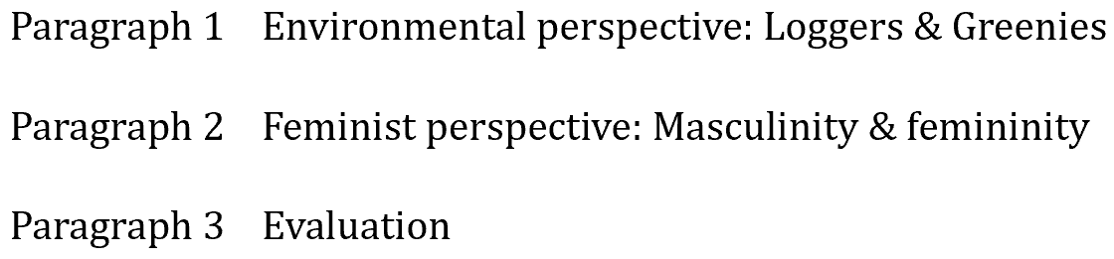

Paragraph structure 4:

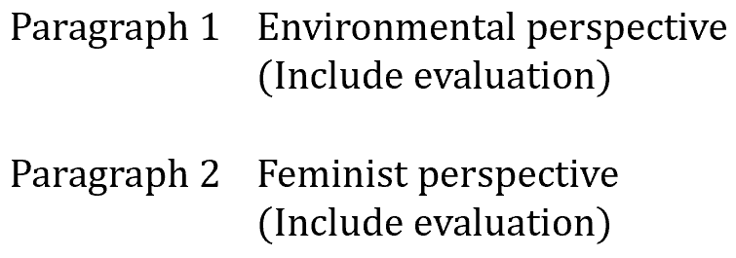

Content: Construct 2 different readings of one studied text.

Q: Consider how other interpretations of a text helped you evaluate its perspective(s).

B1: Masculinity

Nettheim draws the interpretation that men are strong, physically attractive and resourceful.

Martin and Jack are constructed in similar ways through costume and props:

* Rugged outdoor clothing and appearance, trekking backpacks, boots, dark colours.

Martin’s characterisation through his dialogue:

* Lucy: “We’re lucky Jack sent you” after talking about the Jarrah’s vision with the speakers.

Martin’s characterisation through his actions:

* Fixes the generator, fixes the speakers in the trees.
* Bathes Lucy.
* Gives instructions for how to look after Lucy.
* Gets Lucy off the sleeping tablets.
* Joins the family in domestic activities e.g., picking up the kids, laughing with Lucy and organising a picnic.

Martin’s characterisation through his body language:

* His facial expression is much more relaxed and happier when he’s around Lucy and the children, focused and determined when on his mission.

Jack’s characterisation through his actions:

* Drops off supplies to look after Lucy and the kids.
* He leaves Lucy’s bedroom, assumedly giving her the medication that keeps her drowsy.

Martin’s and Jack’s characterisation through props:

* Guns: Symbolic of power.

Martin’s characterisation through Nettheim’s dialogue:

* Nettheim: "It is crucial that Martin is much more than merely enigmatic. The audience needs to find him compelling to watch, strong, physically attractive, surprising, intelligent, resourceful, sexy, compassionate, and ultimately Lucy's saviour and a realistic father figure for Sass and Bike”.

Martin’s characterisation through his actions:

* Nettheim focuses on setting Martin alone at the start of the film, alone in Tasmanian wilderness.
* Through the film script and direction, Martin is in every scene in the film.

Bike’s characterisation through his actions:

* Never talks but contributes to the mission as he draws the pictures that guide Martin to the Tasmanian Tiger.
* Always helps Martin fix things and Sass is either not there or with her mum.

B2: Femininity

Nettheim draws the interpretation that women are

Lucy’s characterisation through setting:

* She’s most often set inside her bedroom or inside the house.
* The bath is coated with dirt and the water from the tap is brown – nothing in the house is looked after.

Lucy’s characterisation through Martin’s and Jack’s actions:

* Jack takes advantage of Lucy’s grief, controlling her by keeping her drowsy on medication.
* Martin changes and begins to take responsibility for the family, connecting with them and acting like the stereotypical head of the family (“renaissance man”, the ideal version of masculinity).

Lucy’s characterisation through Sass’s and Martin’s dialogue:

* “Where’s your mother?”, “Inside in the kitchen” – Tents are set up on the lawn and with campfires, guitars and people.

Lucy’s characterisation through her actions:

* “Do you like it?”, “I liked it better before”, proceeds to wear have hair down.
* looks after Martin’s cut eye when he returns injured.
* Talks a lot but doesn’t really contribute towards the action.

Sass’s characterisation through Jack’s dialogue:

* “Hello princess” (to Sass), “Hello mate!” (to Bike).

Narrative plot of the film:

* Lucy and Sass both die due to arson.

**Q: Consider how other interpretations of a text helped you evaluate its perspective/s.**

Some people see gender inequality as an issue that can be solved by itself with little active action. Some people, particularly feminists, argue that this is not the case.

The film Hunter was released in 2011 and was directed by Daniel Nettheim. Throughout the film, gender stereotypes of masculinity and femininity were perpetuated.

Through the use of characterisation, symbolism, costume and props, the masculine stereotypes of power and idealism were represented.

This representation of men outlines the unattainable standards that hegemonic masculinity has set out, where men are expected to be “compelling to watch, strong, physically attractive, surprising, intelligent, resourceful, sexy, compassionate…”, as said by Nettheim when describing the portrayal of Martin.

Through the use of setting, characterisation and narrative plot, the feminine stereotypes of powerlessness and compliance were represented.

This disappointing representation of women outlines the disempowerment of women portrayed by feminine stereotypes. It depicts the idea that women rely on men for validation and stay in domestic roles, having little power in their decisions.

A feminist perspective would interrogate this representation of men and women where there is a clear difference in empowerment between men and women.

Feminists hold the viewpoint that everyone should be treated equally regardless of factors such as gender, race and ethnicity. This comes from their context that values freedom and equality; that everyone has an equal opportunity to contribute to society and make decisions for themselves.

In addition to this feminist reading, viewers can also interpret the film as a representation of Greenies and loggers.

Many people, particularly Greenies, hold the environment as a priority regardless of the problems to the economy that the preservation of the environment may pose.

Some people, particularly loggers, do not agree with this.

Daniel Nettheim, the director of the 2011 film Hunter, outlines this conflict between the two groups and the clear contrast between their values.

Through the use of dialogue, costume and props, the values of the Greenies of environmental protection were represented.

This representation shows that Greenies hold the environment in the upmost importance, even above economic stability. This comes from their context that values the environment and the belief that people’s jobs should not be at the loss of the environment.

Through the use of symbolism and dialogue, the values of the loggers of economic stability and industry are represented.

This representation shows that loggers view the environment as a resource that can be managed effectively to provide resources and be maintained at the same time.

This comes from the context that values industry and economy and the belief that jobs are necessary for sustaining people.

Through the consideration of this environmentalist reading, I still believe that the feminist reading is completely valid and that through the strong representation of men and women, the overall feminist reading resonates closer to my personal beliefs.

Firstly, Nettheim utilises Martin’s and Jack’s costume and props to allow me to draw the interpretation that men are portrayed by stereotypes to be strong, physically attractive and independent.

Nettheim constructs Martin and Jack in similar ways through their rugged outdoor clothing and appearance, trekking backpacks, boots and dark colours. Martin is a man who can take care of himself in difficult environments. Martin tracks, sets traps, navigates and gets food independently in this wild terrain. This represents the idea of men being strong, independent and powerful, thus perpetuating hegemonic masculinity.

These are characteristics that indicate empowerment.

He fixes the generator and speakers, bathes Lucy, gives instructions for how to look after Lucy, gets Lucy off the sleeping tablets and joins the family in domestic activities such as picking up the children and organising a picnic, characterising him as a ‘Renaissance Man’ – the man who can do all things.

This shows Martin’s power over Lucy and her children as they are dependent on him for maintaining the house, thus perpetuating hegemonic masculinity.

Guns are symbolic of power – the power to protect and harm. Only Martin and Jack carry guns, associating them with this power.

This indicates Martin’s ability to protect Lucy and her children and his ability to defend himself.

He shot a wallaby and gutted it for food, and he leads a Red Leaf agent into an animal trap and shot him, killing him. This shows Martin as cunning and quick-witted.

These are stereotypical traits of hegemonic masculinity, thus perpetuating hegemonic masculinity.

Jack exploits Lucy’s vulnerability from her grief by giving her sleeping medication, keeping her drowsy and powerless.

Martin takes Lucy off the medication and bathes her without consent whilst she is still drowsy.

Through a feminist perspective, we see this scene as an invasion of privacy and an exploitation of her vulnerable state.

Although the bathing scene is not sexualised, it still makes us uncomfortable because of the clear exploitation of power.

This represents the men in the film as having more power, thus perpetuating hegemonic masculinity.

Nettheim says “It is crucial that Martin is much more than merely enigmatic. The audience needs to find him compelling to watch, strong, physically attractive, surprising, intelligent, resourceful, sexy, compassionate, and ultimately Lucy's saviour and a realistic father figure for Sass and Bike”.

The adjectives outlines that the film reinforces the stereotypes of hegemonic masculinity.

Through a feminist reading, this is a disappointing representation of men as it does not reflect the values of freedom and equal opportunity that contemporary society holds.

Although Bike never talks, he contributes to Martin’s mission, guiding him towards the Tasmanian tiger. He also helps Martin fix the generator. This is a continuation of masculine stereotypes, representing Bike as knowledgeable and able to solve problems, survive and take action.

In a society that values equality in both power and freedom, it is important to understand and acknowledge the stereotypes perpetuated by hegemonic masculinity so that we can work towards eliminating this representation of men that limits them both physically and mentally.

The viewpoint expressed by Nettheim on the masculine and feminine stereotypes differ greatly. Nettheim provides the reading that feminine stereotypes disempower women by portraying them as powerless and compliant, and he does this through the use of setting.

For the majority of the film, Lucy is set inside her bedroom or inside the house. This shows that Lucy is seen only in traditional, domestic places such as the bedroom and the kitchen.

Through a feminist reading, this can be seen as a disappointing, limited representation of women, confining them to domestic roles. This perpetuates feminine stereotypes.

When Martin arrives at the house, the bath is coated with dirt and the water from the tap is brown. This gives the impression that nothing in the house is looked after, including the children, and that the house has been neglected.

Lucy is shown to be unable to fulfill her domestic roles of housework and childcare whilst she is coping with her grief. This shows Lucy’s fragility as she is unable to properly cope with Jarrah’s death, showing that Lucy cannot look after herself or her children without a man to help her.

After she is off the sleeping medication, she returns to those domestic activities and fulfills her roles. She also cares for Martin’s cut eye, reinforcing the feminine stereotypes that portrays women as nurturers who stay in domestic roles, and who are not mentally strong and are easily overwhelmed with emotions. This perpetuates female stereotypes.

Lucy also says to Martin “I was doing my PHD in plant science when I met Jarrah”. The fact that she said “was” implies through the past tense that Lucy gave up her career to look after her children, again representing women as nurturers who are confined to domestic activities and thus perpetuating feminine stereotypes.

When Jack arrives at the house, Jack says “Hello princess!” to Sass, and then “Hello mate!” to Bike.

The word “princess” connotes being pretty and innocent, limiting the representation of women.

In contrast, the word “mate” connotes a someone on an equal level, and comes from traditional masculine stereotypes in Australia.

The clear contrast in language reinforces the traditional stereotypes of gender rather than reflecting a more modern representation of people without the confinement of gender.

After Lucy tells Martin of Jarrah’s vision with the speakers of the house being a concert for people all over the world, she says to Martin “We’re lucky Jack sent you”. In this dialogue, the word “lucky” connotes fortune and prosperity.

Martin fulfills Jarrah’s role that Lucy and her children needed, rendering them as dependent on him.

After Martin enquires Lucy about her hair, she says “I had it done in town. Do you like it?”. Martin replies, saying “I liked it better before”. Proceeding this, we see her wear her as before for the rest of the film.

This scene characterises Lucy through her appearance, showing that she needs male validation and that she aims to please men rather than herself in regard to her appearance.

Through a feminist perspective, this disappointing representation of women can be seen to reinforce the feminine stereotype that women are valued for their appearance to a standard set by men.

Lucy and Sass, the only two female characters in the film, are killed due to arson committed by a Red Leaf agent.

This use of narrative plot represents women as vulnerable to men, disempowering women and thus perpetuating the female stereotype of powerlessness and defencelessness. Contemporary society values equal opportunity and freedom.

It is important to address the inequalities that exist because of gender, as the disempowerment of women will only be detrimental to society. To do this, we must understand these inequalities.

Nettheim utilises dialogue to represent the values that the Greenies hold, allowing me to draw the interpretation that the environment is a resource to be protected from anthropogenic activity.

After Simon asks Martin “What would you do if you found a tiger?” and Martin replies with “Not my field”, Simon says “I’d just point his nose due west and tell him to run like the wind. That’s what Jarrah woulda done”.

Through this dialogue, we see that the Greenies value the environment being protected from human intervention and that people cannot be trusted with a valuable part of nature as we would likely destroy it.

Martin is seen wearing felt beanies, wraps and what looks like homemade materials. This use of costume draws on the stereotype that Greenies value homemade, small businesses over the industrial production of large businesses.

It shows that Greenies want to minimise their impact to the environment as it is the large businesses that typically pose a larger impact on the environment, thus perpetuating their values.

When Jack and Martin see the Greenies protestors, in the background there is a sign with the words “Save the Upper Florentine” written on it. This prop shows the Greenies disrupting the industry and promoting their cause, which is to save the forests from logging.

This represents their values, thus perpetuating their value of environmental preservation. In the bathroom, Martin sees the words “Save our native forests”. The word “forests” has been written over in marker with he words “JOBS”, assumedly by a logger. This symbolism shows that the loggers value economic stability and that this value is in conflict with that of the Greenies who value environmental preservation. Jack says that “Logging trees is the only reason there are any people here at all. Or a town”. This dialogue shows that logging is needed in this community for economic stability and that the Greenies are considered as a threat to their jobs. Dougie says to the Greenies “Taking out jobs is personal, mate”. To the Greenies, the protests aren’t personal – they see it as part of the bigger picture. But to the loggers, it’s a personal attack. This represents the loggers’ values of economic stability, thus perpetuating their values. Understanding the political stances of Greenies and loggers is essential to create an appropriate compromise so that both groups are satisfied, balancing both economic stability and environmental preservation to minimise conflict. We cannot neglect one community – both communities must be considered, requiring an understanding of both perspectives.

Nettheim’s speech provides the dominant reading that the stereotypes of hegemonic masculinity and femininity cause a drastically unequal level of empowerment between men and women. This is done through the use of characterisation, symbolism, costume, props and narrative plot. Another reading that the film draws is that protecting the environment from anthropogenic activity, a priority of Greenies, has negative economic consequences on loggers, causing conflict between the two groups. This is done through the use of symbolism, dialogue, costume and props. Considering the portrayal of the women and loggers throughout the film, I maintain my belief that the feminist reading represented resonates more with my personal beliefs. I believe that people should be treated equally and be given equal opportunity regardless of gender, and that understanding and acknowledging the current inequalities is the first step to addressing and eliminating the issues in today’s society.

**Q: Consider how other interpretations of a text helped you evaluate its perspective/s.**

Some people see gender inequality as an issue that can be solved by itself with little active action, but some people, particularly feminists, argue that this is not the case. The film Hunter was released in 2011 and was directed by Daniel Nettheim. Throughout the film, gender stereotypes of masculinity and femininity were perpetuated. Through the use of characterisation, symbolism, costume and props, the masculine stereotypes of power and idealism were represented. This representation of men outlines the unattainable standards that hegemonic masculinity has set out, where men are expected to be “compelling to watch, strong, physically attractive, surprising, intelligent, resourceful, sexy, compassionate…”. Through the use of characterisation and narrative plot, the feminine stereotypes of powerlessness and compliance were represented. This disappointing representation of women outlines the disempowerment of women portrayed by feminine stereotypes. A feminist perspective would interrogate this representation of men and women where there is a clear difference in empowerment. Feminists hold the viewpoint that everyone should be treated equally regardless of factors such as gender, race and ethnicity. This comes from their context that values freedom and equality. In addition to this feminist reading, viewers can also interpret the film as a representation of Greenies and loggers. Many people, particularly Greenies, hold the environment as a priority regardless of the problems to the economy that the preservation of the environment may pose. Some people, particularly loggers, do not agree with this. Nettheim outlines this conflict between the two groups and the clear contrast between their values. Through the use of dialogue, costume and props, the values of the Greenies of environmental protection were represented. This representation shows that Greenies hold the environment in the upmost importance, even above economic stability. This comes from their context that values the environment and the belief that people’s jobs should not be at the loss of the environment. Through the use of symbolism and dialogue, the values of the loggers of economic stability and industry. This representation shows that loggers view the environment as a resource that can be managed effectively to provide resources and be maintained at the same time. This comes from the context that values industry and economy and the belief that jobs are necessary for sustaining people. Through the consideration of this environmentalist reading, I still believe that the feminist reading is completely valid and that through the strong representation of men and women, the overall feminist reading resonates closer to my personal beliefs.

Firstly, Nettheim utilises Martin’s and Jack’s costume and props to allow me to draw the interpretation that men are portrayed by stereotypes to be strong, physically attractive and resourceful. Nettheim constructs Martin and Jack in similar ways through their rugged outdoor clothing and appearance, trekking backpacks, boots and dark colours. Martin is a man who can take care of himself in difficult environments. Martin tracks, sets traps, navigates and gets food independently in this wild terrain. This represents the idea of men being strong, independent and powerful, thus perpetuating hegemonic masculinity. He fixes the generator and speakers, bathes Lucy, gives instructions for how to look after Lucy, gets Lucy off the sleeping tablets and joins the family in domestic activities such as picking up the children and organising a picnic, characterising him as a ‘Renaissance Man’ – the man who can do all things. This shows Martin’s power over Lucy and her children as they are dependent on him for maintaining the house, thus perpetuating hegemonic masculinity. Guns are symbolic of power – the power to protect and harm. Only Martin and Jack carry guns, associating them with this power. This indicates Martin’s ability to protect Lucy and her children and his ability to defend himself. He shot a wallaby and gutted it for food, and he leads a Red Leaf agent into an animal trap and shot him, killing him. This shows Martin as cunning and quick-witted. These are stereotypical traits of hegemonic masculinity, thus perpetuating hegemonic masculinity. Jack exploits Lucy’s vulnerability from her grief by giving her sleeping medication, keeping her drowsy and powerless. Martin takes Lucy off the medication and bathes her without consent whilst she is still drowsy. Through a feminist perspective, we see this scene as an invasion of privacy and an exploitation of her vulnerable state. Although the bathing scene is not sexualised, it still makes us uncomfortable because of the clear exploitation of power. This represents the men in the film as having more power, thus perpetuating hegemonic masculinity. Nettheim says “It is crucial that Martin is much more than merely enigmatic. The audience needs to find him compelling to watch, strong, physically attractive, surprising, intelligent, resourceful, sexy, compassionate, and ultimately Lucy's saviour and a realistic father figure for Sass and Bike”. The adjectives outlines that the film reinforces the stereotypes of hegemonic masculinity. Through a feminist reading, this is a disappointing representation of men as it does not reflect the values of freedom and equal opportunity that contemporary society holds. Although Bike never talks, he contributes to Martin’s mission, guiding him towards the Tasmanian tiger. He also helps Martin fix the generator. This is a continuation of masculine stereotypes, representing Bike as knowledgeable and able to solve problems, survive and take action. In a society that values equality in both power and freedom, it is important to understand and acknowledge the stereotypes perpetuated by hegemonic masculinity so that we can work towards eliminating this representation of men that limits them both physically and mentally.

The viewpoint expressed by Nettheim on the masculine and feminine stereotypes differ greatly. Nettheim provides the reading that feminine stereotypes disempower women by portraying them as powerless and compliant, and he does this through the use of setting. For the majority of the film, Lucy is set inside her bedroom or inside the house. This shows that Lucy is seen only in traditional, domestic places such as the bedroom and the kitchen. Through a feminist reading, this can be seen as a disappointing, limited representation of women, confining them to domestic roles. This perpetuates feminine stereotypes. When Martin arrives at the house, the bath is coated with dirt and the water from the tap is brown. This gives the impression that nothing in the house is looked after, including the children, and that the house has been neglected. Lucy is shown to be unable to fulfill her domestic roles of housework and childcare whilst she is coping with her grief. This shows Lucy’s fragility as she is unable to properly cope with Jarrah’s death, showing that Lucy cannot look after herself or her children without a man to help her. After she is off the sleeping medication, she returns to those domestic activities and fulfills her roles. She also cares for Martin’s cut eye, reinforcing the feminine stereotypes that portrays women as nurturers who stay in domestic roles, and who are not mentally strong and are easily overwhelmed with emotions. This perpetuates female stereotypes. Lucy also says to Martin “I was doing my PHD in plant science when I met Jarrah”. The fact that she said “was” indicates through the past tense that Lucy gave up her career to look after her children, again representing women as nurturers who are confined to domestic activities and thus perpetuating feminine stereotypes. When Jack arrives at the house, Jack says “Hello princess!” to Sass, and then “Hello mate!” to Bike. The word “princess” connotes being pretty and innocent, limiting the representation of women. In contrast, the word “mate” connotes a someone on an equal level, and comes from traditional masculine stereotypes in Australia. The clear contrast in language reinforces the traditional stereotypes of gender rather than reflecting a more modern representation of people without the confinement of gender. After Lucy tells Martin of Jarrah’s vision with the speakers of the house being a concert for people all over the world, she says to Martin “We’re lucky Jack sent you”. In this dialogue, the word “lucky” connotes fortune and prosperity. Martin fulfils Jarrah’s role that Lucy and her children needed, rendering them as dependent on him. After Martin enquires Lucy about her hair, she says “I had it done in town. Do you like it?”. Martin replies, saying “I liked it better before”. Proceeding this, we see her wear her as before for the rest of the film. This scene characterises Lucy through her appearance, showing that she needs male validation and that she aims to please men rather than herself in regard to her appearance. Through a feminist perspective, this disappointing representation of women can be seen to reinforce the feminine stereotype that women are valued for their appearance to a standard set by men. Lucy and Sass, the only two female characters in the film, are killed due to arson committed by a Red Leaf agent. This use of narrative plot represents women as vulnerable to men, disempowering women and thus perpetuating the female stereotype of powerlessness and defencelessness. Contemporary society values equal opportunity and freedom. It is important to address the inequalities that exist because of gender, as the disempowerment of women will only be detrimental to society. To do this, we must understand these inequalities.

Nettheim utilises dialogue to represent the values that the Greenies hold, allowing me to draw the interpretation that the environment is a resource to be protected from anthropogenic activity. After Simon asks Martin “What would you do if you found a tiger?” and Martin replies with “Not my field”, Simon says “I’d just point his nose due west and tell him to run like the wind. That’s what Jarrah woulda done”. Through this dialogue, we see that the Greenies value the environment being protected from human intervention and that people cannot be trusted with a valuable part of nature as we would likely destroy it. Martin is seen wearing felt beanies, wraps and what looks like homemade materials. This use of costume draws on the stereotype that Greenies value homemade, small businesses over the industrial production of large businesses. It shows that Greenies want to minimise their impact to the environment as it is the large businesses that typically pose a larger impact on the environment, thus perpetuating their values. When Jack and Martin see the Greenies protestors, in the background there is a sign with the words “Save the Upper Florentine” written on it. This prop shows the Greenies disrupting the industry and promoting their cause, which is to save the forests from logging. This represents their values, thus perpetuating their value of environmental preservation. In the bathroom, Martin sees the words “Save our native forests”. The word “forests” has been written over in marker with the words “JOBS”, assumedly by a logger. This symbolism shows that the loggers value economic stability and that this value is in conflict with that of the Greenies who value environmental preservation. Jack says that “Logging trees is the only reason there are any people here at all. Or a town”. This dialogue shows that logging is needed in this community for economic stability and that the Greenies are considered as a threat to their jobs. Dougie says to the Greenies “Taking out jobs is personal, mate”. To the Greenies, the protests aren’t personal – they see it as part of the bigger picture. But to the loggers, it’s a personal attack. This represents the loggers’ values of economic stability, thus perpetuating their values. Understanding the political stances of Greenies and loggers is essential to create an appropriate compromise so that both groups are satisfied, balancing both economic stability and environmental preservation to minimise conflict. We cannot neglect one community – both communities must be considered, requiring an understanding of both perspectives.

Nettheim’s speech provides the dominant reading that the stereotypes of hegemonic masculinity and femininity cause a drastically unequal level of empowerment between men and women. Another reading that the film draws is that protecting the environment from anthropogenic activity, a priority of Greenies, has negative economic consequences on loggers, causing conflict between the two groups. Considering the portrayal of the women and loggers throughout the film, I maintain my belief that the feminist reading represented resonates more with my personal beliefs. I believe that people should be treated equally and be given equal opportunity regardless of gender, and that understanding and acknowledging the current inequalities is the first step to addressing and eliminating the issues in today’s society.